**Marital status:**

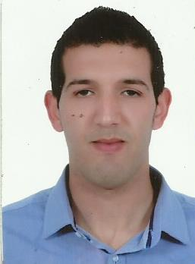

**Name : TALAA**

**First name : Oussama**

**Date of birth : 22-08-1990**

**Nationality : Moroccan**

**Address : Street ouhoud , N° 4 ,Bettana salé ,**

**11040 MOROCCO**

**Phone N° : +973 6676 3135**

**Email :** [**chawnil_sale@hotmail.com**](mailto:chawnil_sale@hotmail.com)

**Relationship : Single**

**Formation:**

**2010  : Bachelor's level, option: modern literature.**

**2011/2013  : Diploma in hotel ( service restoration ) to touarega rabat .**

**2012/2013  : Diploma in hotel (kitchen-pastry) centre Mohamed VI sale**

**Internship and experience :**

**2008 : work (catering ben said) work (catering mahmoud)**

**2009 : Extra a pub puzzle ( RABAT)**

**2010 : Extra to hotel BARCELOS (SAIDIA)**

**2011/2013 : Learning to hotel Rabat ( service restoration )**

**2013 : Hotel shehrezade Mercure ( Rabat).**

**2013 : Extra to oriental BAY BEACH ( SAIDIA )**

**2014 : Pup TOO MUCH (RABAT AGDAL )**

**: Pup MARACANA ( RABAT )**

**2018/2019 : Al mansoori Catering ( BAHREIN )**

**Languages:**

* **Arabic : Langue native**
* **French : Read , write , speak**
* **English : Basic concept**

**Hobbies:**

**: Available of continuation**

**: Swimming**

**: Fit physically**

**: Collective spirit**